SIMATS ENGINEERING
ASSESSMENT TOOL 1
COURSE NAME: Operating Systems
COURSE CODE: CSA-0409

COURSE OUTCOME COVERED
CO3: Evaluate memory management mechanisms such as linking, paging, and segmentation to determine their effectiveness for different system requirements
Assessment Tool Weightage: 40%

QUESTIONS: 5 Total Marks: 50
Experiment Questions:
1.Design and implement a program to simulate the translation of a logical address into a physical address using base and limit registers. The program should accept logical address as input, check for validity, and compute the corresponding physical address. Display appropriate messages for valid and invalid addresses.
Program :
#include <stdio.h>
int main() {
int base, limit, logical, physical;
printf("Enter base register: ");
scanf("%d", &base);
printf("Enter limit register: ");
scanf("%d", &limit);
printf("Enter logical address: ");
scanf("%d", &logical);
if (logical >= 0 && logical < limit) {
physical = base + logical;
printf("Valid logical address\n");
printf("Physical address = %d\n", physical);
} else {
printf("Invalid logical address\n");
printf("Address is outside the limit\n");
}
return 0;
}
Output :
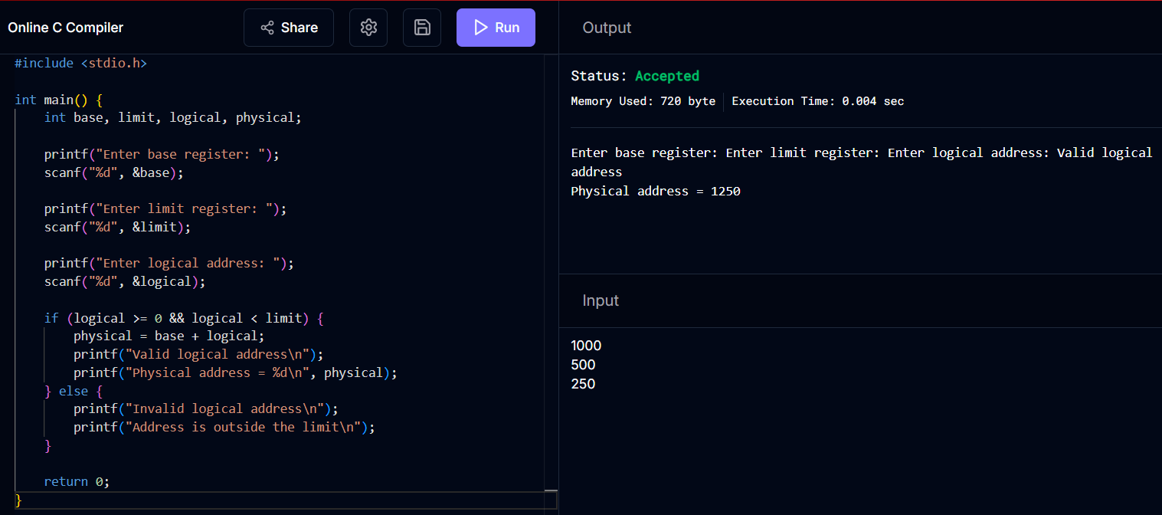
2.Write a program to demonstrate the paging memory management scheme. The program should divide memory into fixed-size pages and frames, accept page number and offset as input, and compute the corresponding physical address using a page table.
Program :
#include <stdio.h>
int main() {
int pageSize, page, offset, frame;
int pageTable[20];
int physical;
printf("Enter page size: ");
scanf("%d", &pageSize);
printf("Enter number of pages: ");
int n;
scanf("%d", &n);
printf("Enter page table entries:\n");
for (int i = 0; i < n; i++) {
printf("Page %d -> Frame: ", i);
scanf("%d", &pageTable[i]);
}
printf("Enter page number: ");
scanf("%d", &page);
printf("Enter offset: ");
scanf("%d", &offset);
if (page >= 0 && page < n && offset >= 0 && offset < pageSize) {
frame = pageTable[page];
physical = frame * pageSize + offset;
printf("Page Number = %d\n", page);
printf("Frame Number = %d\n", frame);
printf("Physical Address = %d\n", physical);
} else {
printf("Invalid page number or offset\n");
}
return 0;
}Output: :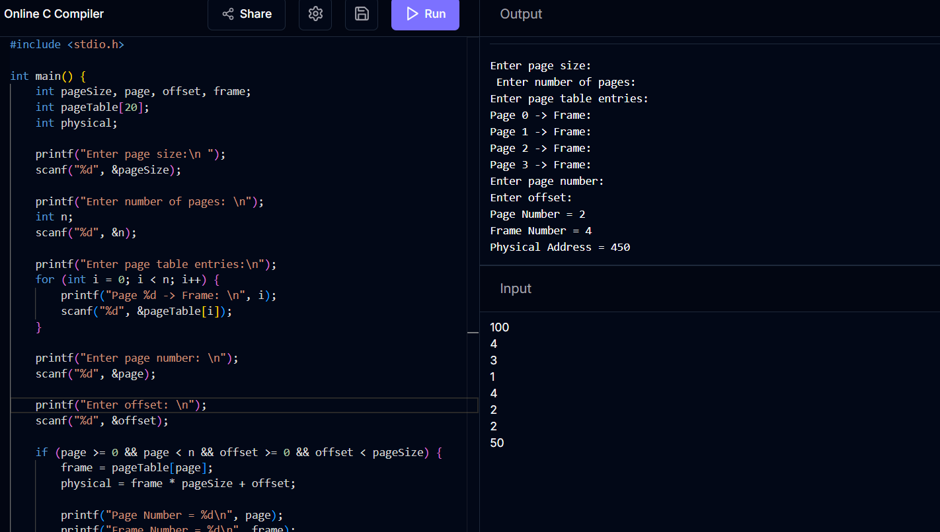
3.Develop a program to simulate a page table. The program should allow the user to input page table entries and logical addresses, then map them to physical addresses. Clearly show how page numbers are translated into frame numbers.
Program :
#include <stdio.h>
int main() {
int pageTable[20];
int n, page, offset, frame, physical;
printf("Enter number of pages: ");
scanf("%d", &n);
printf("Enter page table entries:\n");
for (int i = 0; i < n; i++) {
printf("Page %d -> Frame: ", i);
scanf("%d", &pageTable[i]);
}
printf("\nPage Table\n");
printf("Page\tFrame\n");
for (int i = 0; i < n; i++) {
printf("%d\t%d\n", i, pageTable[i]);
}
printf("\nEnter page number: ");
scanf("%d", &page);
printf("Enter offset: ");
scanf("%d", &offset);
if (page >= 0 && page < n) {
frame = pageTable[page];
physical = frame * 100 + offset;
printf("\nPage Number = %d\n", page);
printf("Page %d is mapped to Frame %d\n", page, frame);
printf("Physical Address = %d\n", physical);
} else {
printf("Invalid page number\n");
}
return 0;
}
Output :
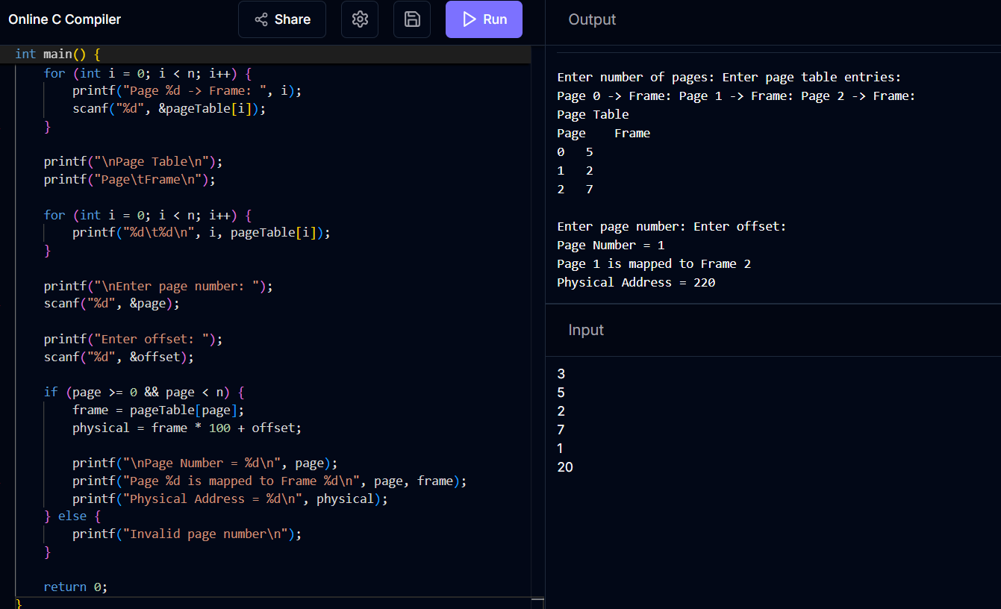
4.Implement a program to simulate the working of a Translation Lookaside Buffer (TLB). The program should demonstrate how TLB improves memory access time by calculating the effective memory access time with and without TLB.
Program :
#include <stdio.h>
int main() {
float hitRatio;
float tlbTime = 10;
float memoryTime = 100;
float withTLB, withoutTLB;
printf("Enter TLB hit ratio (0 to 1): ");
scanf("%f", &hitRatio);
if (hitRatio < 0 || hitRatio > 1) {
printf("Invalid hit ratio\n");
return 0;
}
withoutTLB = 2 * memoryTime;
withTLB = hitRatio * (tlbTime + memoryTime)
+ (1 - hitRatio) * (tlbTime + 2 * memoryTime);
printf("\nMemory access time without TLB = %.2f ns\n", withoutTLB);
printf("Effective access time with TLB = %.2f ns\n", withTLB);
if (withTLB < withoutTLB)
printf("TLB improves memory access time\n");
else
printf("TLB does not improve memory access time\n");
return 0;
}
Output :
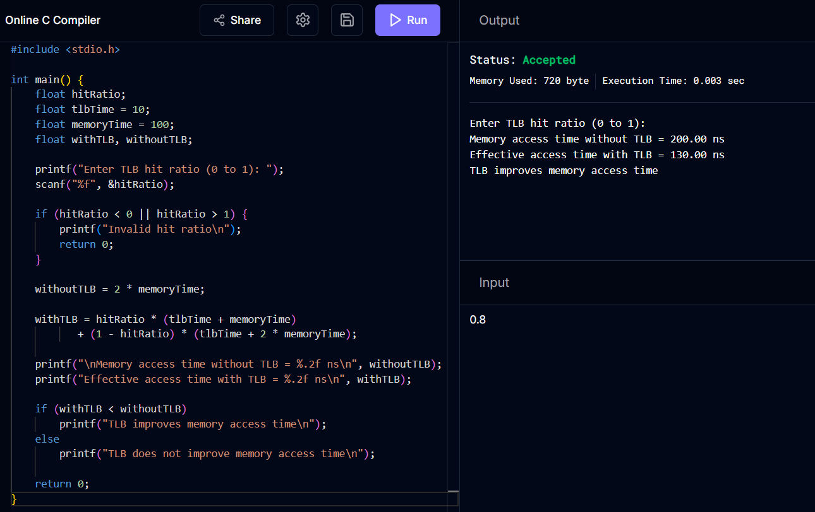

5.Write a program to illustrate memory protection using base and limit registers. The program should verify whether a given logical address lies within the valid range and prevent unauthorized access.
Program :
#include <stdio.h>
int main() {
int base, limit, logical;
printf("Enter base register: ");
scanf("%d", &base);
printf("Enter limit register: ");
scanf("%d", &limit);
printf("Enter logical address: ");
scanf("%d", &logical);
if (logical >= 0 && logical < limit) {
printf("Access Allowed\n");
printf("Logical address %d is within the valid range\n", logical);
printf("Physical address = %d\n", base + logical);
} else {
printf("Access Denied\n");
printf("Unauthorized memory access\n");
}
return 0;
}
Output :
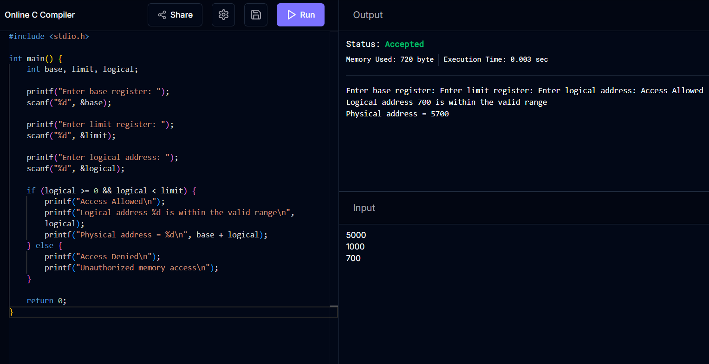

RUBRICS FOR CALCULATION:

Criteria | Weightage (Marks) | Level 4 – Exemplary (Full Marks) | Level 3 – Proficient | Level 2 – Developing | Level 1 – Beginning
Conceptual Understanding | 35 Marks | Demonstrates clear, complete, and in-depth understanding of OS concepts (types, structure, system calls) | Good understanding with minor gaps | Basic understanding with some misconceptions | Poor or incorrect understanding
Accuracy of Answers | 25 Marks | All answers are correct, precise, and relevant | Mostly correct with minor errors | Partially correct with noticeable errors | Mostly incorrect or irrelevant
Application of Knowledge | 15 Marks | Effectively applies concepts to scenarios/questions | Applies with minor mistakes | Limited or partial application | No meaningful application
Completeness of Response | 15 Marks | All parts of each question are fully answered | Most parts covered with small omissions | Some parts missing | Incomplete answers
Clarity & Presentation | 10 Marks | Clear, well-structured, and neatly presented answers | Understandable with minor issues | Somewhat unclear or poorly structured | Difficult to understand

